

**AFRICAN INSTITUTE FOR PROJECT MANAGEMENT STUDIES**

**Course: Post Graduate Course in Grants Management**

**Course Module: Module 4**

**Student Name: OKOT Charles**

**Admission Number: Aipms/300/2019**

**Module Submission Dateline: 31st December 2019.**

**Module Four**

1. ***What is pay-per-click advertising? What factors have to be considered when advertising in this way?***

**Pay per click advertising;**

PPC is a method of online advertising used by Internet search engines, networks and content sites, such as blogs, in which businesses can display ads that appear alongside the results of Internet searches. Thus, when a consumer conducts an Internet search, say for a particular type of digital camera, he or she will see advisements from a variety of related merchants. The beauty of this marketing model is that the advertiser pays only when a consumer actually clicks on the ad and, thus, through to his or her business’s Web site.

**Factors to consider when doing pay per click advertising.**

**General factors to be considered.**

After understanding the Socio economic status of the target customers, demographics of the target customers, Kind of products to be advertised, Location of potential customers, Availability of internet to potential customers; the following factors play key role in successful pay per click advertising;

**Keyword Selection**

Proper keyword selection is vital when it comes to creating your website or any marketing campaign you run (whether on-site or off-site.) However, in PPC, proper keyword research will help you know that phrases that commonly searched for you to target, and balance your budget at the same time.

**Keyword Bidding**

After you’ve chosen the specific keywords for your PPC advertising campaign, you need to bid on them. Ideally, the higher you offer, the higher you’ll rank on your PPC advertising. Competition for these keywords can be tight, so bid as high as your pay per click marketing budget will allow. Then, you can make adjustments over time as you gradually see the results.

**Targeted Copy.**

So, you’ve already set up your campaign and then decided on a particular offer. Then, you build a relevant ad copy that will convey your message clearly to your prospects. Ideally, the ad copy should be related directly to your specific offer. Aside from that, it should be engaging and compelling enough for prospects to click on your ad.

**Landing Pages.**

Your landing page needs to have at least three things ‒ an excellent copy, great title, and clear call to action. The title is vital because it tells users in a straightforward way that they’ve arrived on the right location based on the ad copy they’ve clicked. A compelling ad copy is an excellent way to keep your PPC budget on track. When your ad copy targets a specific audience, then the number of clicks will decrease, but the quality of clicks will. As a result, the click costs will go down, and the conversions from highly qualified leads will rise.

**Website Analysis**

What exactly happens after the click-through, when web visitors land on your website or landing page? Well, website analysis can help you answer that question.

**The Offer**

Your PPC is like an online version of your advertising. So, like different types of advertising, the offer should be an essential part of your campaign. No matter what business or industry you’re in, your campaigns should be built on a highly engaging and compelling offer. When you make your PPC ads, ensure that your offer gives your prospective clients value.

1. ***What is distinctive about how communication takes place in social media?***

**Communication on social media is driven by the following factors;**

**Social media provides an Inside Perspective of Faraway Places.**

Social media allows people to connect with anybody on the social media irrespective of location, religion, race etc. there by opening up the whole world to a single user. Social media has enabled people from all over the world to share their story. Besides the internet essentially connecting the world, Snapchat was the first to really give people an inside perspective of foreign places. With the addition of live story streams and Story Explorer, users are able to get a peek of what life in other cities, states, and countries is like.

**Social media communication created a Sense of Urgency and a Need to Share.**

Social media communication can be instant, by reading the information of pages, or talking to a helper or getting immediate feedback. Social media platforms like Facebook and Twitter have manifested the need to constantly broadcast our lives on the internet. In basic communication, humans transmit information and receive instant feedback. The integration of texting, messaging and emailing, however, has enabled senders and receivers to sit and dwell before responding.

**Social media provides the ability to Broadcast Moments Live.**

Social media live (Facebook live) began as a way to innocently share even more with your friends, but then it became increasingly used for serious matters. Besides changing the way, we communicate major events through video, Facebook and Instagram Live have also opened up new marketing potential for universities.

1. ***Explain the primary social media channels a nonprofit would be likely to use?***

**Google+:**

Google+ was launched in the year 2011 and gained a total of 500 million users, at least 200 million of these are active. Unlike the other social networking sites, this service stretches its reach even to the other platforms provided by Google. With its unique feature that uses circles to group connections, you can share updates to specific people whom you know will be interested about it.

Signing up for Google+ can benefit nonprofit in sharing news to certain groups only. If you have important donors or new volunteers or even charitable institutions that you wish to inform on a specific update, then form those circles and avoid sharing general posts. You can also start a hangout and talk to your friends online. Encourage them through live video chat and let them know how grateful your nonprofit would be if they’d be a part of it.

**Facebook**

Who wouldn’t recognize the social site that has already gained 1 billion active users? Facebook has made a huge success for the past years making it a top choice for communication by people and businesses. With its continuous development, many users are being provided with easier and faster way of interacting with their friends.

Creating a Facebook page for your organization will help you reach larger audience. Share updates, links, photos, and even videos of what you’ve been up too. Encourage your online friends or fans to take part in your cause.

Host online contests like photo or page shares and gain more funds to continue your fundraising activities. You can also develop an application on this media channel and use it to attract more donors. An example could be an interactive game wherein players can give credits as donations in exchange for a special item.

**Pinterest**

They say that pictures speak louder than words and this is what Pinterest has proven. This photo sharing website that uses a pin board-style layout has been added to the list of popular social networking channels. It has even been recorded that Pinterest drives more traffic than Twitter does which is something that businesses would love to know.

As for your nonprofit, being a part of Pinterest is a good move to let users view photos of your organization. You can upload pins related to your past or current activities. Images that would show how volunteers help for a cause could encourage others to take part too. Add up different boards and share pins that will make your fundraising activities more engaging and interesting.

You can create specific boards for your upcoming campaigns. Label each according to the cause or name of your activity, and then include creative photos of the event. If you’re hosting a photo or art contest, then you can do the same thing.

**Twitter.**

When you register your nonprofit on Twitter, you can tweet quick updates about your nonprofit’s activities. You can spread news, ask for donations or volunteers, and even let others know how they could help your cause.

**YouTube**

A video-sharing channel that is still one of the most visited websites is YouTube. By just uploading your own video on this platform, online viewers can already watch what you wish to share. People can also vote if they like your post and the number of viewers will be recorded. Countless nonprofits have already used this site to be known by many, and some even gained success in delivering their message online like Big Brothers Big Sisters and March of Dimes.

Upload a video on your latest charitable works and let YouTube users be inspired. Speak to them on what your nonprofit organization’s all about through the video. Make them feel that acting as a volunteer or donor is a job that will benefit those who are in need.

Being a part of something that easily connects you with a lot of people is a great move to let your nonprofit’s voice be heard. With the help of social media websites like the ones shared here, you won’t have a hard time communicating and even gaining the people that will support your mission of helping others.

1. ***Describe the product life cycle model. What benefits might such an analysis offer fundraisers? What difficulties or drawbacks might there be in attempting to use the model in the context of fundraising?***

**Meaning of product life cycle;**

The product life cycle is an important concept in marketing. It describes the stages a product goes through from when it was first thought of until it finally is removed from the market. Not all products reach this final stage. Some continue to grow and others rise and fall.

The product life cycle is broken into four stages: introduction, growth, maturity, and decline. This concept is used by management and by marketing professionals as a factor in deciding when it is appropriate to increase advertising, reduce prices, expand to new markets, or redesign packaging.

**What benefits might such an analysis offer fundraisers.**

Product life cycles helps for project continuity and mix as indicated in the cycle below.

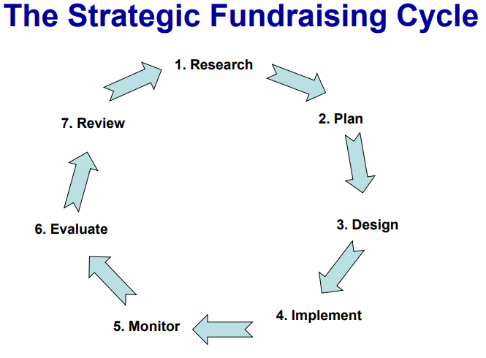

**Fundraising product life cycle.**

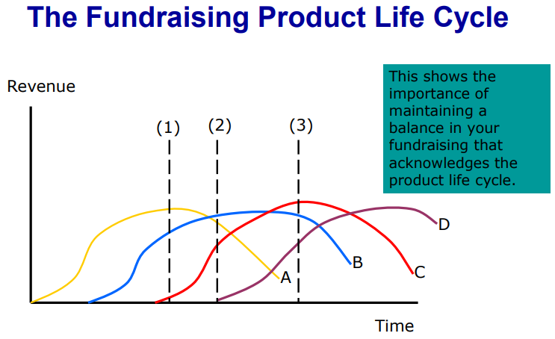

Fundraising product life cycle, provides a clear picture of the different projects stages, and how they are integrated. This helps the fundraisers generate competitive strategies to ensure sustainable funding sources. Product life cycle, helps the fundraising team to generate strategic decisions at the early stage so as to overcome product barriers, and maximize the profit margin. At early stages of the cycle product incur significant R&D, market-launch expenses and cash flows are often negative, therefore fundraiser invest capitals in to the product at early stages. Small firms typically have fewer resources; they often require outside financing, or lending to start the processes.

**Drawbacks of using Product Life Cycle for Fundraising.**

**Unpredictability:**

While a product’s life may be limited, it is very hard for manufacturers to predict exactly how long it is likely to be, especially during the new product development phase. While most manufacturers are very good at making the best decisions based on the information they have, consumer demand can be unpredictable, which means they don’t always get it right.

**Change:**

The unpredictability of a products life span comes from the fact that all the factors that influence the product life cycle are constantly changing. For example, changes in the cost of production or a fall in consumer demand due to the launch of alternative products, could significantly alter the duration of the different product life cycle stages.

**The Curve is a Model:**

Critics of the product life cycle have claimed that some manufacturers may place too much importance on the suggestions the model makes, so that it eventually becomes self-fulfilling. To illustrate the point, if a company uses the product life cycle curve as a basis for its decisions, a decrease in sales may lead them to believe their product is entering the Decline stage and therefore spend less on promoting it, when the opposite strategy could help them to capture more market share and actually increase sales again.

1. ***Fundraising audits can be undertaken by external suppliers (agency staff or consultants), or the task can be allocated to internal staff. What do you think would be the advantages and drawbacks associated with each of these approaches?***

**What is an Internal Audit?**

An internal audit is the evaluation of all aspects of an organization by an internal auditor, i.e. one who works as an employee of the organization. He keeps tabs on the financial reporting, accounting, operations, risk management, internal controls and all other such aspects of an organization.

**Advantages of Internal Fundraising Audit.**

**1] More Effective Fundraising Management**

One of the biggest benefits of an internal audit is that it facilitates more effective management of the organization. The internal auditor will be able to point out any weaknesses of the organization in the fundraising operations or internal controls of the company. So the management can use these insights to better the chances of achieving their goals.

**2] Ongoing Review of Fundraising.**

The process of internal audit gives the organization a unique opportunity to conduct a review of the performances in the ongoing year itself. They do not have to wait for the end of the year to review the company’s performance. This also means that if they are not on the correct path, this will help them change course and correct their mistakes immediately.

**3] Performances of Fundraising Staff Improve.**

The staff of the company remains alert and active. This is because there is the fear of their mistakes being caught by the internal auditor almost immediately. This will help improve their efficiency and performance. Also, they do not attempt to defraud the company for the same reasons. And on the other hand, it is a good morale booster for honest employees.

**4] Ensures Optimum Use of Fundraising Resources.**

One other benefit of the process of internal control is that it can be used as a tool to promote the optimization of resources. It will help point out the areas in which resources are being underutilized or wasted. And then these can be corrected. It will help control the costs and expenses of the company.

**5] Division of Fundraising Work**

Internal audit helps promote the division of labor. It is important to keep a check on and observe the activities of all the departments and all of their employees. Division of labor will help in achieving this.

**Limitations of Internal Audit**

Now let us move on to the limitations of internal audit. Like every good thing has a flip side, there exist some concerns about these limitations of internal audit. Let us take a look.

**1] Shortage of Qualified Staff**

The work of an audit requires years of study and experience. An inexperienced auditor can cause more damage than good. So usually, the company will find it somewhat difficult to find enough qualified staff members for the process of an internal audit.

**2] Time Lag**

There will always be a time lag between accounting and auditing. Internal audit cannot begin till the accounting is complete. They cannot be done simultaneously. So if the accounting process is delayed, so is the internal audit.

**3] Ignorance of Management**

Unlike a statutory audit, the findings of an internal audit are not published or made available to all. Their findings are only forwarded to the management. sometimes even if an internal audit reports points out to the shortcomings of the company or the errors in the financial statements, the management may not take corrective action.They can choose to ignore such findings and then there will be no benefit gained from the internal audit.

**Below is articulated the advantage and disadvantage of external audit,**

**01. Advantages:** The vital advantage of an external audit is that it makes it easier to compare diverse companies as the auditors articulate their judgments about the equality of measures. Of a company is given a good judgment then it means that it is follow the law. It also assists in following positive values. An audit will remain the managers from frustrating to pamper in deceptive performs as it is a resources of responsibility. It confirms to dependability and honesty of the consequences.

**01. Disadvantages:** The only disadvantage of an external audit can be the expenses concerned because you have to pay the auditors and also guarantee that you preserve comprehensive records of all the interactions which engage a lot of expenses.

**02. Advantages:** the external audit is essential if the internal auditor is unfaithful to the organization then the external auditor can verify the accounts of the company to identify whether the company has fair and true accounts or there are some unfair and false accounts are there so this is the grounds the company assigns the external for the company.

**02. Disadvantages:** External examines contributors may be secluded from the relaxed networks of the organization, putting them at a weakness when navigate the surroundings. External service providers do not offer a systematic internal recruiting ground for future senior managers.

03. Advantages: The errors whether committed unknowingly or consciously are exposed by the process of external audit and its attendance prevents their occurrence in the future. No one will try to commit an error or fraud as the accounts are subject to audit and hence they will have a fear of being detected.

03. Disadvantages: Discretion might be violated if external individuals have access to susceptible in rank.

1. ***“Our objective is to enter the corporate fundraising market.” What do you think of this as a fundraising objective? In what ways might it be improved?***

**Corporate fundraising';**

Is defined as income generated through a partnership with a commercial organization, which may provide money, skills or other resources to the charity.

**Ways to improve corporate fundraising.**

**Audit existing skill set.**

Your fundraiser may be an accomplished jack-of-all-trades, but does he or she possess the specific blend of skills needed to succeed in corporate fundraising? As well as having someone with commercial acumen and an understanding of the local/regional business environment, you’ll need a formidable researcher, networker, proposal writer, presenter, negotiator and project manager – as well as a creative thinker and a thick-skinned marketeer. If you can tick off all of these qualities, congratulations! You appear to have a corporate fundraiser in your midst, and you’re ready to go.

**Get everyone on board.**

As talented as your fundraiser may be, his or her success will be dependent upon the support of others. Corporate fundraising is always a team sport, so it’s vital that your chief executive, trustees and programme staff are enthused and involved – whether it’s by facilitating introductions, attending meetings, preparing information for proposals or speaking passionately about the charity’s work at events and presentations.

**Focus on warm prospects**

When it comes to the question of which businesses to target, be sure to prioritize those that have supported you before, or where you have a connection – no matter how tenuous. Take time to review your own contacts, your chief executive’s or trustees’ networks and all of your suppliers and advisers. Systematically research their business, their senior personnel and their charity partners. Think carefully about the common ground, what you can offer them and who is best placed to make the initial approach. Finally, remember that cold approaches rarely bear fruit, and should be the last item on your corporate fundraiser’s to-do list.

**Ensure timescales are realistic.**

If your charity’s budgets are under severe pressure, corporate fundraising is unlikely to provide a swift answer to your prayers. Lucrative, strategic partnerships can take months to broker and immediate, large cash donations are rare. Be prepared to play the long game: spend time getting to know each company and its staff so that you can develop a proposition tailored to their CSR or other business objectives. This stage is crucial, but can be long and drawn out – and is often made harder by anxious trustees breathing down your neck, asking you where the big money is!

**Develop a strong corporate product.**

It’s understandable if you feel rather intimidated by the prospect of working with big business, but keep reminding yourself that all companies are run by people. So the chances are, they’re going to be attracted to similar aspects of your charity’s work as your individual supporters are – whether it’s a cataract operation, a cancer nurse or a cute guide dog puppy. Play to your strengths by focusing your corporate offer on what the charity does best, and what differentiates you from the competition

***b) Distinguish between market segmentation and product differentiation. When are these approaches typically appropriate***?

Distinguish between market segmentation and product differentiation.

**Product Differentiation**

A small business can differentiate its product using marketing techniques, by physically changing the product or by changing the price. Using marketing, you can create a brand or image in the mind of consumers by pointing out the difference between your product and those of your competitors. For example, your advertising can show that while your product may cost the same as your competitor’s, it lasts longer, making it less expensive to use. If you sell tennis shoes, you can reinforce the toes, making it a longer-lasting shoe that appeals to frequent players who wear out their shoes. Lowering or raising the price of a product differentiates you from your competition.

**Market Segmentation**

Market segmentation is the process brands use to divide their target market into smaller segments of people that share common characteristics to optimize their marketing, advertising and sales efforts.

Because consumers have different needs, even when shopping for the same product, it’s important to know who is buying your product. This will help you plan your marketing, product development and pricing. You can sell a higher-priced version of your product with extra features in specialty stores to attract young, affluent singles, and sell another version with fewer features at a lower cost to young families or seniors. You can sell one version of your product to consumers, and another to businesses.

**When is product differentiation appropriate.**

When there is a lot of competing products in the market, the increased competition has divided the demand among different players in the market. This has made it very important for businesses to make their customers understand what different they have to offer. Besides making the product survive in the market.

**Product differentiation is important for the following reasons:**

* Product differentiation translates the product attributes into benefits.
* It answers the biggest question of the customers – ‘What’s in for me?’.
* It gives the customers a reason to purchase the brand’s product and repeat the purchase.
* It increases the recall value of the product.
* It increases brand loyalty and builds brand equity.
* Attribute-based differentiation is important for the brand to defend their price from levelling down to the bottom part of the price spectrum.

**When is market segmentation appropriate.**

When the fundraising audience large, the broader their preferences, needs, and opinions become, which can put the organization marketing message at risk for being irrelevant to a large group of people.

Reference

WSI White Paper, Prepared by: WSI Corporate 2010.

Fundraising, Philip Lee, Chief Executive, Epilepsy Action, U.K. 2018

<https://productlifecyclestages.com/product-life-cycle-challenges>. January 4th 2020.